# Fault Tolerant

## Evolving towards fault tolerant system

### Traditional system

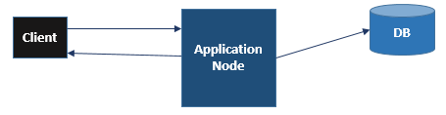

When there is a single Application node and DB node, now there is a single point of failure for both of the systems.

So what we need to do?

### Replication

The first thing which comes is **replicate** both Application and DB instances.

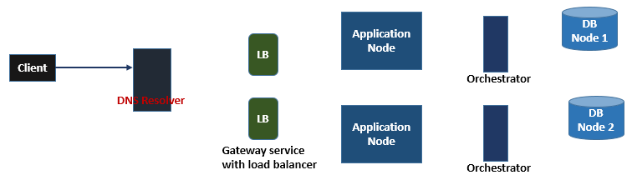

Everything needs to be replicated the **DB Coordinator**, **Load Balancer**. So now the client will be pushed back and will talk with **DNS Resolver** and the flow will be distributed and carry forwarded.

Now the entire system is placed in one **region** and what if in worst case that entire system fails because of some natural calamities or something.

### Region replication

So to avoid above kind of entire system failure scenario. We will replicate the entire system in **multiple regions.**

